Materials
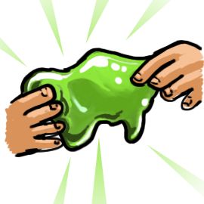
- 1/4 cup of water
- 1/4 cup of white craft glue
- 1/4 cup of liquid starch
- Food coloring
- Mixing bowl/bag
- Mixing utensil
Instructions
- Pour 1/4 cup of glue into your mixing bowl/bag
- Pour 1/4 cup of water to the mixing bowl/bag already containing glue
- Stir the glue and water together thoroughly
- Add 2-3 drops of food coloring
- Add 1/4 cup of liquid starch and stir
Can I touch the slime?
Yes! Once you’ve finished creating your slime, continue to play with it to make it more stretchy and easier to hold. Store your slime creation in a bag when you are not playing with it.
How does it work?
Who doesn’t love slime?! The slime you’ll create in this experiment is a result of glue being what’s called a liquid polymer. The tiny molecules within the glue are in strands, like a chain. Once liquid starch is added, the polymer glue’s strands hold together, giving it that slimy texture. The starch links all the polymer strands together, keeping it together!
Make it an experiment
- Does changing the amount of glue, water, or liquid starch affect the feel of the slime?
- Do different types of glues make better slime?
- What happens to the slime if stored in different environments (e.g. hot or cold temperatures, out of the bag, etc.)?
- How does changing the amount of each ingredient change how the slime turns out?
- Are there any other individual or combinations of ingredients other than liquid starch that you can use to link the polymer strands?

