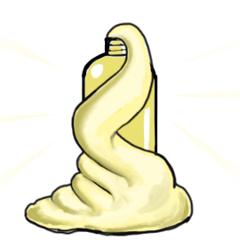
Materials
- Flask, or plastic soda/water bottle
- Hydrogen peroxide (3% for small-scale, 30% for large-scale) (Caution: Irritant)
- Liquid dish washing soap
- Food coloring
- Potassium iodide (Caution: Irritant)
NOTE: The foam could overflow from the flask/bottle, so be sure to do this experiment on a washable or disposable surface, or within a contained environment (e.g., on a tray, in a container)
CAUTION: Hydrogen peroxide and potassium iodide can irritate the skin and eyes. Wear a lab coat, safety goggles, and gloves.
Instructions
- Add 50 mL of 3% or 30% (depending on scale of activity) hydrogen peroxide to flask/bottle
- Add 2-3 drops of food coloring
- Add about 1 tablespoon of liquid dish soap into the bottle
- Here comes the fun! Have the students count down from 3 and pour 10 mL of potassium iodide into the flask, then watch the foaminess begin!
Can I touch the foam?
The reaction will release energy shortly after the potassium iodide is poured into the flask, and the toothpaste will foam up and likely overflow from the bottle. If you look closely, you will notice steam coming from the toothpaste shortly after the reaction has started. Anyone who would like to touch the foam must wait 5-10 seconds after overflow, due to high temperatures. Additionally, it is necessary to have gloves on both hands if you would like to touch the foam. This is because there could be unreacted peroxide remaining which can irritate skin and eyes.
How does it work?
The foam you’ll create in this experiment is filled with tiny foam bubbles containing oxygen. The potassium iodide acted as a catalyst, which is used to speed up a reaction. When the potassium iodide broke apart the oxygen from the hydrogen peroxide, it did so rapidly. Therefore, it created tons of bubbles and foamed up. The flask/bottle getting warm was due to what is called an exothermic reaction – creating heat!
Clean Up
It is recommended to have the flask in a large bin, a tray at the least, that is placed on a flat surface with a washable or disposable tablecloth. Once the reaction is completed, wash out the flask with soap and water, and dry. Wash out the bin with hot water.

