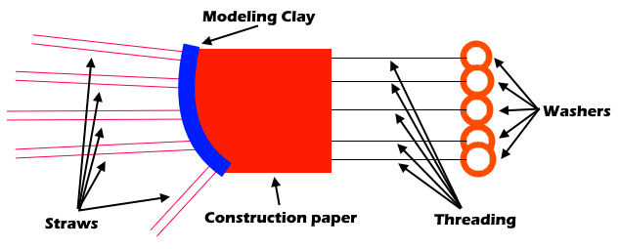
Materials
- Bendy straws
- Rubber washers
- Modeling clay/play dough
- Threading
- Reusable gloves
- Construction paper
- Tape
Instructions
- Before designing our hand model, think about the way your hand and fingers move together. With your helping hand, you should be able to flex and release the fingers, press down a key on a keyboard, and be precise enough to select one key at a time.
- Sketch your design and brainstorm what your hand model will look like. Think of how you can use the materials give in this activity to create a functioning replica of the human hand.
- To start building our hand model, let’s create something to hold all our materials together. Make a fist with your hand and wrap the construction paper around your palm and top of your hand. Tape the ends of the construction paper so it stays in place.
- Take five straws that will represent your model’s fingers. Cut each of them to the same length as each of your fingers. Cut small holes in each of the straws at the same spots your real fingers can bend.
- Insert a long thread into each of the straws and tape one end of the string to the top of each straw. Wrap the other end of each straw around a rubber washer and tie a knot.
- Use modeling clay or play dough to create the knuckles area. It should be a long and decently thick piece of clay with four holes in it, to slide the straws through.
How does it work?
The human hand is an impressive piece of anatomy and, with some training, they can perform complex tasks like manipulating tools, typing on keyboards, and using pens to create art. Our hands are durable and strong enough to hold heavy weights, but also delicate enough to knit sweaters and pet our favorite animals. Scientists have studied many aspects of human anatomy and biology to create human-like hands to be used as prosthetics. Prosthetics are artificial devices that replace missing body parts and intend to restore normal functions of the body. Today, you’ll be creating your own prosthetic hand model! To test the flexibility and functionality of our prosthetic, we’re using a keyboard as the test subject. Your prosthetic hand should be strong enough to press down a key on a standard keyboard, and flexible enough to only press one at a time!

